Map Trip Worksheet

Name:________________________

You are planning a trip from Sandburg to a city or town in Illinois. Once you have found your destination use the expressways as much as possible.

Keep in mind:
- Your gas cost (*currently about) $2.50 per gallon.
- Your car gets 18 miles per gallon.
- Your average speed is 60 mph (at 60 mph you travel about 1 mile per minute).

Your destination is___________________________.

Leave from Sandburg
It takes about (9.5)miles to 1-55
It takes about (8) miles to I-80

- What was the route that you took? Make sure you write down which direction you are traveling.

- How many miles was it to your destination?_________________

- How many gallons of gas did you use to get to your destination?______________

- What was the total cost of gas for your trip?________________

- What was your total driving time?__________________

Directions And Mapping Expressway
Two Numbers:
- You are going east or west if the back number is even
Example:I-80, I-88
- You are going North or South if back number is odd
Example: I-57, I-55
Three Numbers:
- An even number in front is a bypass. (A bypass is a road which goes around a city) Example): I-465
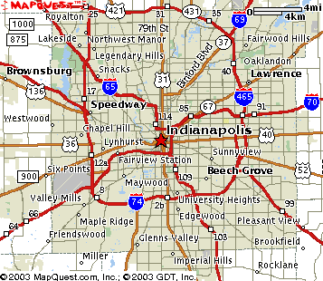
Street Directions
- Avenues (names) run North and South
- Example: LaGrange Rd. and Harlem Ave. and.Ridgeland Ave.
• Numbers increase as you go west
• Numbers decrease as you go East
- Streets (numbers) run East and West.
• Example: 143rd. -135th -131st.
• Numbers decrease as you go North
• Numbers Increase as you go South
- The dividing line between North and South is Madison Street
- The dividing line between East side and West side is State Street
House Addresses:
- West and North side of the street even Numbers: 13544
- East and South side of the street odd numbers 13543

How to Calculate Miles Per Gallon take
- Current Odometer Reading – (Last Odometer Reading) / Gallons used since last fill up.
- From the example above for the last two rows
- (24,785 - 24,475) = 310 miles driven on the tank since the last fill up.
- 310 miles / 10.2 gallons used = 30.4 miles / gallon
- Note this only works properly using fill up to fill up, since putting less than a fill up would not tell how much fuel was used to arrive at the same reference point.

